**IST659 – Data Admin Concepts & Db Mgmt**

**Lab 5 - Ramasamy Seenivasagamani – Sanjeev**

Alter table Candidate and Interviewer to add a column for the Candidate and Interviewer’s Middle name initial. This column is optional.

--Adding column to Candidate table

alter table Candidate

add CMiddlenameInitial varchar(10);

--Adding column to Interviewer table

alter table Interviewer

add CMiddlenameInitial varchar(10);

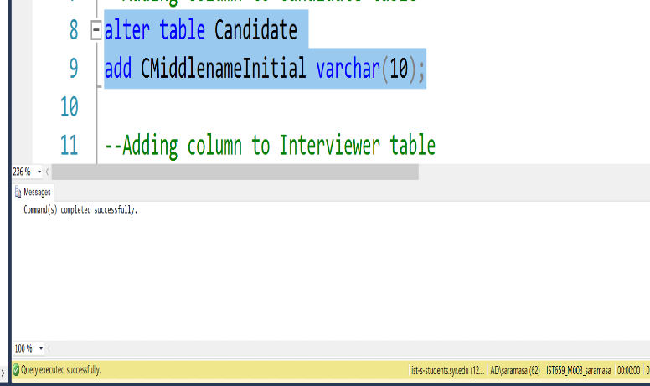

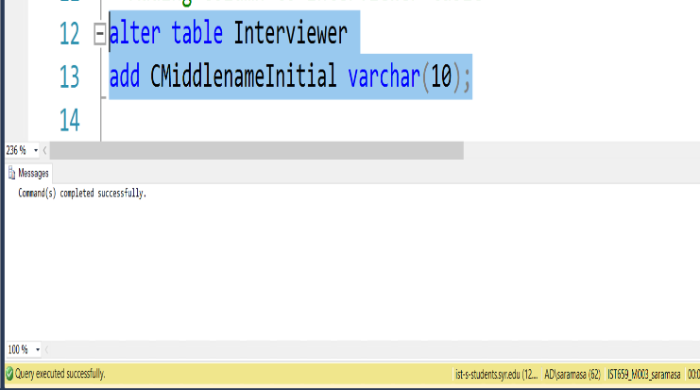

Alter tables to let users input state abbreviate name instead of full name. For example, ifstate name is “New York”, change it to “NY”. Similarly, if state name is “California”,change it to “CA” and so on. Change all the tables that have the state column. (Candidate,Interviewer, Company). Also alter the data we inserted to fit this new datatype. Hint: ifthere are already data in these tables and the data do not conform to the new data type,you might need to remove the data before you can alter the table.

--Updating the State Name to its abbreviation and altering the data type

update Candidate

set CState ='NY' where CState='New York'

update Interviewer

set IState ='NY' where IState='New York'

update Company

set CoState ='NY' where CoState='New York'

--Changing the column's datatype to accomadate the updated user input

alter table Candidate

ALTER COLUMN CState char(2);

alter table Company

ALTER COLUMN CoState char(2);

alter table Interviewer

ALTER COLUMN IState char(2);

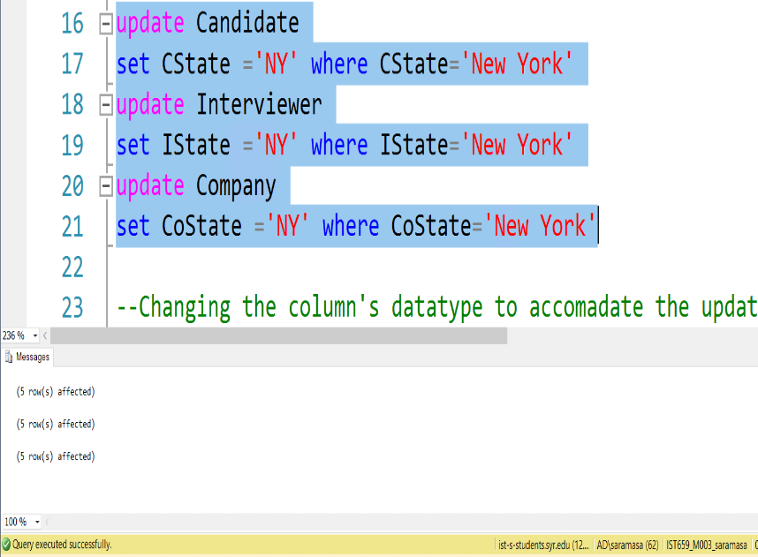

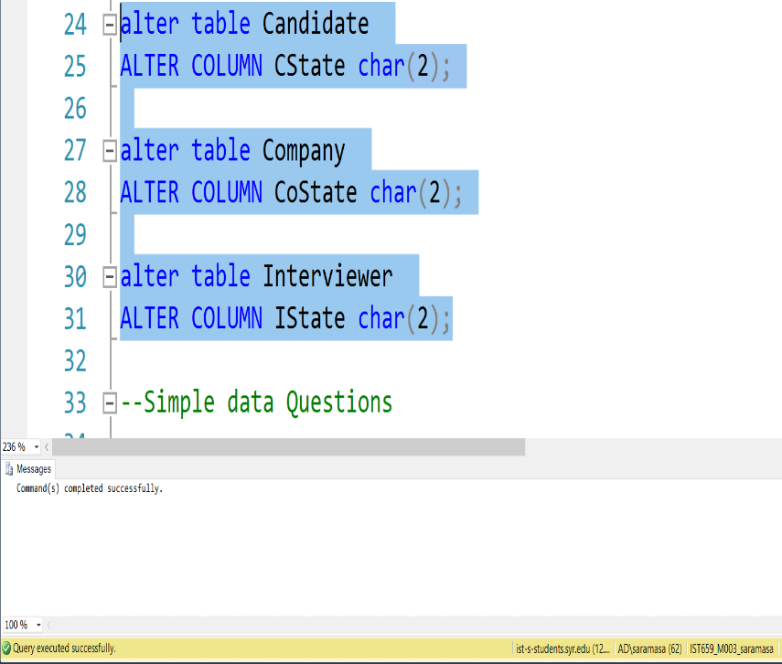

Find all Candidates who live in area having zip code “13225”. Show all columns.

--a. Candidates who live in area having zip code “13225”

select * from Candidate where CZip=13225

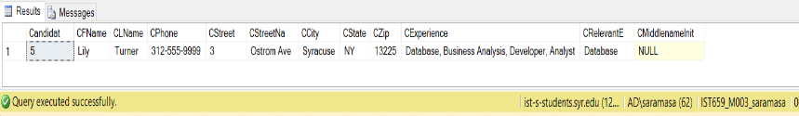

--b. Interviewers living on “Lancaster Ave”.

select IFName, ILName, ICity, IState from Interviewer where IStreetName ='Lancaster Ave'

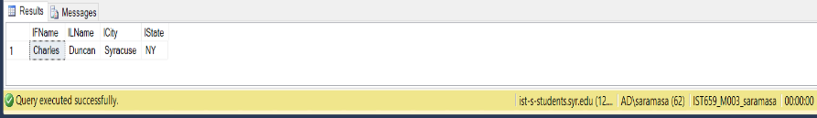

--c Update the table ‘Interview’, set date as ‘2013-09-28 00:00:00.000’ where

-- interviewID is ‘1’. Find all interviews that took place on 28th day in the month of

-- September, 2013. Show Interviewer ID and Position ID.

Update Interview

set InterviewDate ='2013-09-28 00:00:00.000' where InterviewId = 1

select InterviewerId, PositionId from Interview where Day(InterviewDate)=28

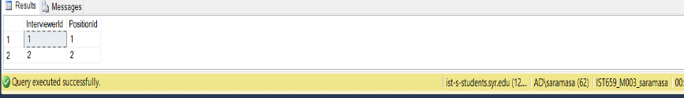

--d. Positions that are not available for 'Executive' level.

select * from Position where PositionLevel not in ('Executive')

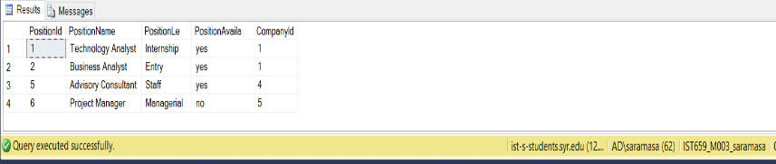

--e. Interviews that exceeded 2 rounds

select InterviewerId, CandidateId, InterviewDate from Interview where RoundNumber>2

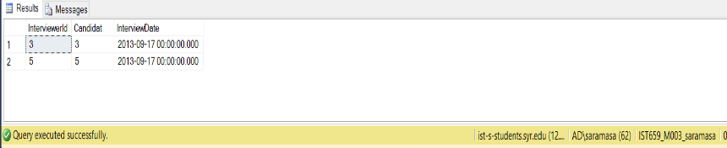

--4. a. Number of candicates in each zip code

select CZip, count(CandidateId) as Number_of_Students from Candidate group by CZip

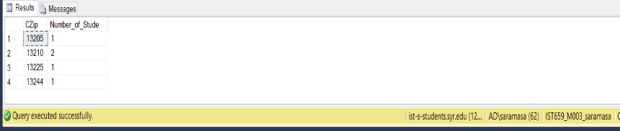

--b. Sort interview table by round number

select InterviewId, InterviewerId, InterviewDate from Interview order by RoundNumber

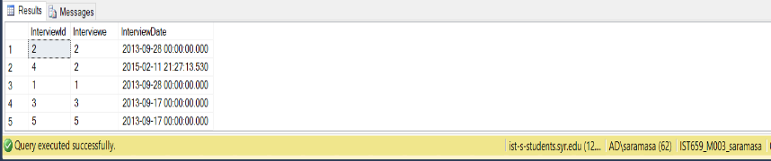

--c. Sort interview table by interview date

select InterviewId, InterviewerId from Interview order by InterviewDate

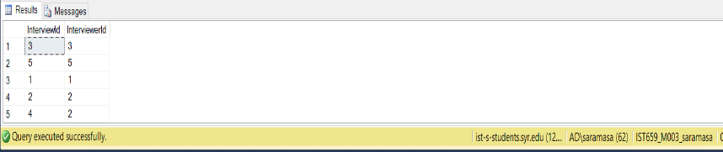

--d. Avg, Min & Max round numbers for each candidate in the interview table

select CandidateId, avg(RoundNumber) as Average_Round_Numbers, min(RoundNumber) as Min_Round_Numbers, max(RoundNumber) as Max_Round_Numbers from Interview group by CandidateId

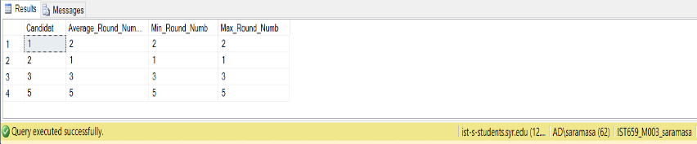

--e. Candidates with average round number less than 3

select CandidateId, avg(RoundNumber) as Average_Round_Number from Interview group by CandidateId having avg(RoundNumber)<3

